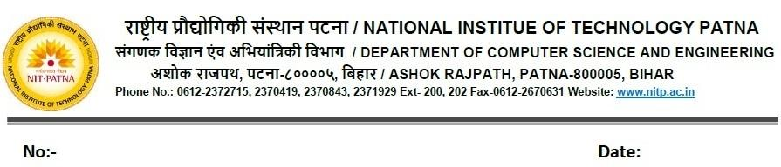

***CS34110 Discrete Mathematics and Graph Theory***

**L-T-P-Cr: 3-0-0-3**

**Pre-requisites:** High school mathematics.

**Objectives/Overview:**

* To know the classical notions of logic, set theory, main formulas in combinatorics, main definitions and some classical theorems on graphs and apply graphs in concrete situations.
* The purpose of the course is to provide the students with several concepts and methods of the number theory, graph theory and their applications in engineering and computer science.

**Course Outcomes:**

At the end of the course, a student should:

| **Sl. No.** | **Outcome** | **Mapping to POs** |
| --- | --- | --- |
|  | Apply methods of counting methods in problem solving. | PO-1 |
|  | Apply permutation and combination for solving counting problem | PO-1, PO-2 |
| **3** | Apply recurrence relation to solve counting problem | PO-2, PO-4 |
|  | Represent problems in computer science using graphs and trees. | PO-1 |
|  | Apply the concept of planarity of graph to solve computer science application. | PO-3, PO-2 |
|  | Apply the concept of colorings in computer science application | PO-2 |

**UNIT I: Counting Lectures:12**

Basic of Counting, product rule, sum rule, Principle of inclusion-exclusion and its application,

Tree Diagram method, pigeon-hole principle, Generalized Pigeonhole Principle, Permutation and Combination, Generalized Permutation and Combination;

**UNIT II:** **Advanced Counting Techniques Lecture: 10**

Recurrence Relation, solving linear Recurrence Relation, Master Theorem, Recurrence Relation for solving counting problem, Generating function,

**UNIT III: Graphs Lectures: 14**

paths, cycles, walk; Trees and their characterization, diameter, center, degree sequences and realizability, Eulerian trails, Hamiltonian cycles---sufficient conditions, connectivity—cut points, bridges, block, Whitney’s theorem, Planarity, colourability, Coverings and independence, digraphs, tournaments, orientability, Matrix representation of graphs,

**Text/Reference Books**

1. Discrete Mathematics and Its Applications with Combinatorics and Graph Theory, 8th Ed, by Kenneth Rosen, Kamala Krithivasan, Mc Graw Hill.
2. Discrete Mathematics for Computer Scientists and Mathematicians 2Nd Ed by Mott Kandel & Baker, PHI
3. Discrete Mathematics. K. A. Ross, Ch. R. B. Wright, Prentice Hall Inc., 1992
4. Graph Theory & its application. Narsingh Deo, TMH
5. Discrete Mathematical structures and applications to Computer Science. by Trembly & Manohar, TMH.